**EXPERIMENT NO 9**

**Aim** :- Design a 3D Mountains using Blender.

**Objective** :- To Design a 3D Mountains using features of Blender 2.8.

**STEPS TO DESIGN A 3D MOUNTAIN-**

Step-1 Open Blender workspace select the existing cube and delete it.

Step-2 Go to Edit Menu and select ‘Preferences’ option. Select Add-ons in the appeared dialogue box, then tick the ‘Add-Mesh-Landscape’ option.

Step-3 Now to Add, and then add Landscape.

Step-4 In the Add Landscape dialogue box, change the settings as per preference in order to make the mountain more realistic.

Step-5 Add another landscape, to add more scenic beauty. Repeat the Step 4 for this landscape too.

Step-6 Add a plane in the background and in the surface.

Step-7 At last add texture to the mountain. Also add texture of soil and sky to the planes inserted in the previous step.

Step-8 Now render the final model.

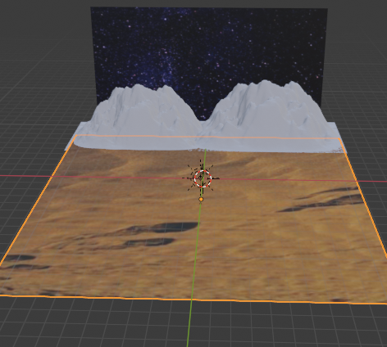

Link:

<https://drive.google.com/drive/folders/1XmUepJzHmMvXMubq8OTMBbupE4t9hXu_?usp=sharing>

